Installation Guide for Mississippi Vendor Challenge Prototype

UNISYS

Version <1.0> Status: Review

13 October 2016

Contents

1 Introduction 5

2 Prerequisites before Starting installation: - 5

3 Step 1-Java Setup 5

4 Step 3-Setting up MYSQL Schema. 5

5 Step 2-Install Apache Tomcat: 6

6 Step 5- Final Deployment 14

# Introduction

This document describes the prerequisites and installation of Mississippi Vendor Challenge Prototype to a target environment. The target environment taken here is a Windows 2008 R2 server.

# Prerequisites before Starting installation

There are few prerequisites for installing the Mississippi Vendor Challenge Prototype. Following list of software’s are installed.

1. Java 8
2. MYSQL Server ([download here](https://fastdl.mongodb.org/win32/mongodb-win32-x86_64-2008plus-ssl-3.2.1-signed.msi?_ga=1.119338447.779510770.1454951010))
3. Apache Tomcat 8.0 ([download here](http://apache.mirrors.hoobly.com/tomcat/tomcat-8/v8.0.37/bin/apache-tomcat-8.0.37.exe)).

# Step 1-Java Setup

Set the Java path from [Java Path Setup](https://kaanmutlu.wordpress.com/2013/04/26/setting-the-java_home-in-windows-7-64-bit/)

Set the following environment variables:

JAVA_HOME= C:\Program Files\Java\jdk1.8.0_60

Path=%JAVA_HOME%\bin;

# Step 3-Setting up MYSQL Schema.

Application database scripts can be find at \WEB_INF\classes\sql folder in the War File.

1. Create CWS Database.

Run the following command to create the database in the MYSQL Command Line to create the database

**Command:**

* Create database CWS



1. Create user and grant privilege

Run the following command to create the ‘CWS user.

* CREATE USER 'cws'@'localhost' IDENTIFIED BY 'cws';



Run the following command to grant ‘CWS’ user all privileges to CWS database.

* GRANT ALL PRIVILEGES ON cws. * TO 'cws'@'localhost';



1. Creating Schema.

Go command prompt run the below command

* mysql -u {username} -p {databasename} < create-schema.sql



1. Creating metadata.

Go command prompt run the below command

* mysql -u {username} -p {databasename} < metadata.sql

# Step 2-Install Apache Tomcat:

**Step-1:** Double Click apache-tomcat-8.0.37.exe to install apache tomcat.

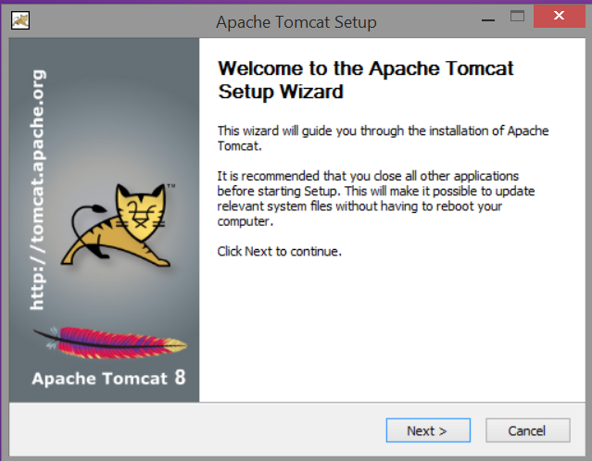

Click Next.

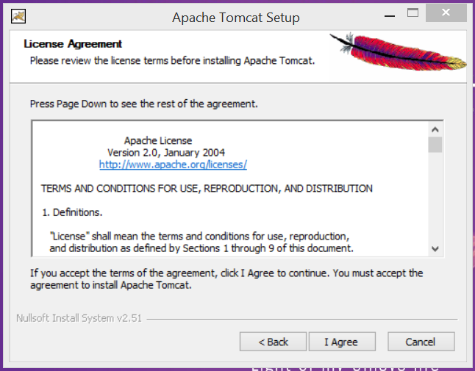

Click “I Agree”.

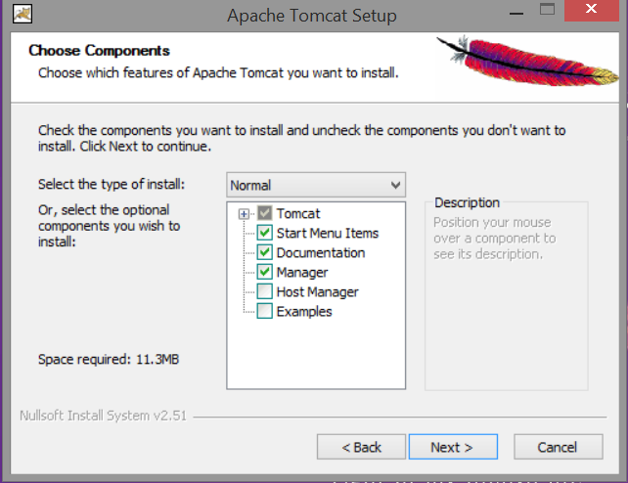

Leave the configuration as it and click on “Next”.

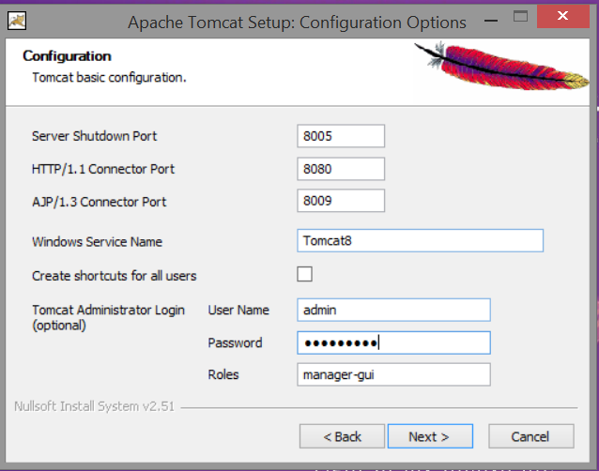

Leave default the ports configuration as is, provide admin username and password and click “Next”.

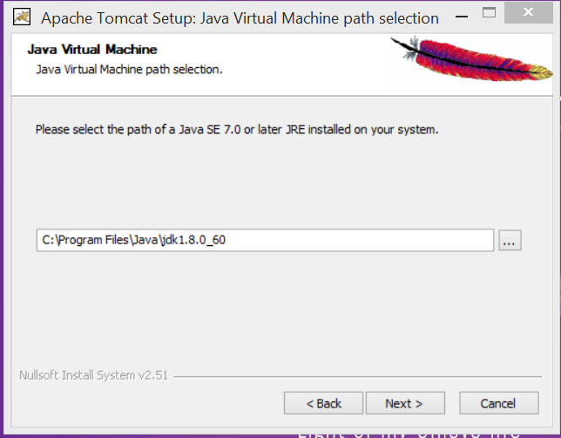

Configure the JDK or JRE Path and Click on “Next”.

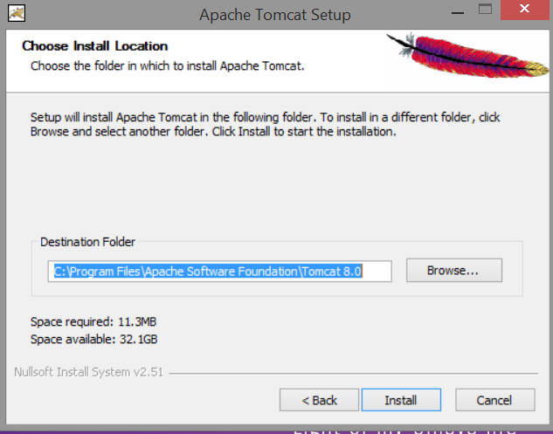

Configure the Destination Folder and Click on “Install”.

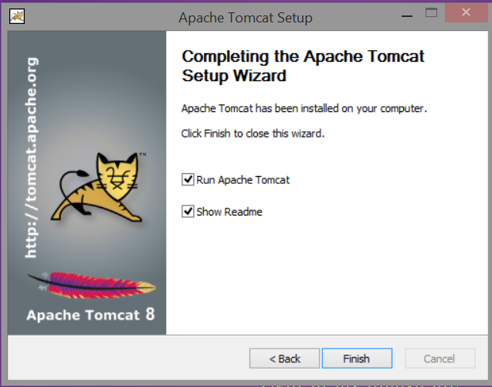

After Installation you should be able to see the “Apache Tomcat 8.0 tomcat8” service as below. If not started “Start” it.



# Compiling the Code

Installation of Apache Maven:

1. Apache Maven ([download](http://redrockdigimark.com/apachemirror/maven/maven-3/3.3.9/binaries/apache-maven-3.3.9-bin.zip)).

After downloading maven unzip the zip file to a folder (example: C:\maven).

Add maven path to Path variable.

SET PATH=%PATH%;C:\MAVEN\ apache-maven-3.3.9\bin;

Compiling the code:

1. Go to the project checkout location, open command prompt.
2. Go to “mscws-portal-api” by typing

* Cd mscws-portal-api



1. Now run below command to compile and package the code.

Command: mvn clean install –DskipTests



# Final Deployment

Copy the “mscws-portal-api-1.0.0-SNAPSHOT.war” from <code-checkout-location>\mscws-portal-api\target\ to <TOMCAT_DIR>\webapps\.

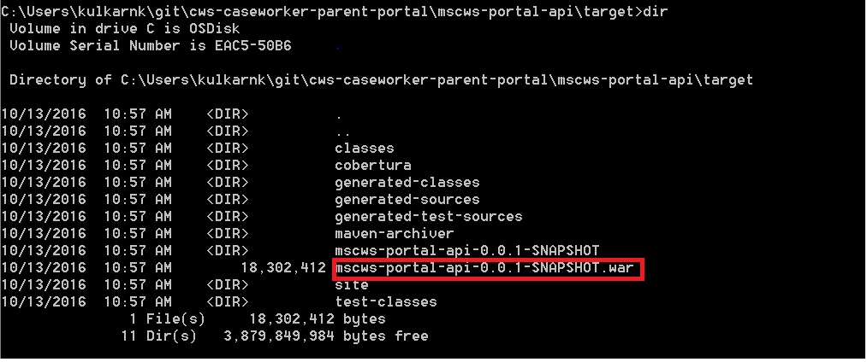

Restart the server.

Ping the below URL: http://<host>:<port>/ mscws-portal-api-1.0.0-SNAPSHOT /resources/index.html#/

For example:

<http://52.24.122.11:8080/mscws-portal-api/resources/index.html#/>